APPLICATION DEVELOPMENT APPROACHES
Traditional Development
vs
Low-Code Development

A Comparative Report on Modern Software Delivery Approaches
Prepared: July 2026
Akshaya S
Roll No: 241401009

1. Introduction
Choosing how to build a software application is one of the most consequential decisions a team makes. Two dominant approaches exist today: traditional, hand-written development and low-code development, which uses visual tools and prebuilt components to assemble applications with minimal manual coding. This report compares both approaches across speed, cost, flexibility, and scalability to help you choose the right method for your next project.
1.1 What is Traditional Development?
Traditional development means writing an application's logic, interface, and infrastructure line-by-line in a programming language such as Java, Python, or JavaScript. Developers have complete control over architecture, performance, and integrations, making this approach ideal for complex, large-scale, or highly specialized systems.
1.2 What is Low-Code Development?
Low-code development uses visual, drag-and-drop interfaces, prebuilt templates, and reusable components to build applications with little manual coding. Platforms like OutSystems, Mendix, and Microsoft Power Apps let both professional developers and non-technical "citizen developers" build working applications rapidly.
Figure 1: Average development time across project types
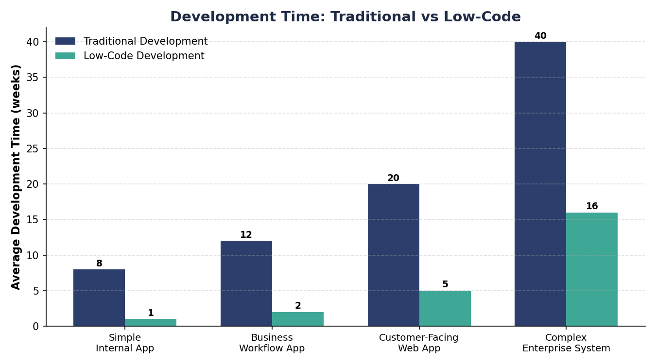

2. Side-by-Side Comparison
The table below breaks down how traditional and low-code development compare across the factors that matter most when planning a project.
Aspect | Traditional Development | Low-Code Development
Development Speed | Slower — every feature hand-coded from scratch | Much faster — drag-and-drop components & prebuilt modules
Coding Skill Required | High — requires trained software developers | Low to moderate — accessible to citizen developers
Customization | Virtually unlimited flexibility | Limited to platform's building blocks & APIs
Cost | Higher upfront cost (salaries, time, infra) | Lower upfront cost, but recurring platform licensing fees
Scalability | Highly scalable with proper architecture | Good for most apps; can hit platform-imposed limits
Maintenance | Requires ongoing developer involvement | Easier updates via visual editors, less code to manage
Integration | Full control over APIs & third-party systems | Depends on platform's built-in connectors
Best Suited For | Complex, mission-critical, highly custom systems | MVPs, internal tools, workflow apps, rapid prototypes
Vendor Lock-in | None — code is fully owned | Possible — tied to the chosen platform
Time to Market | Weeks to months (or longer) | Days to a few weeks

3. Capability Comparison
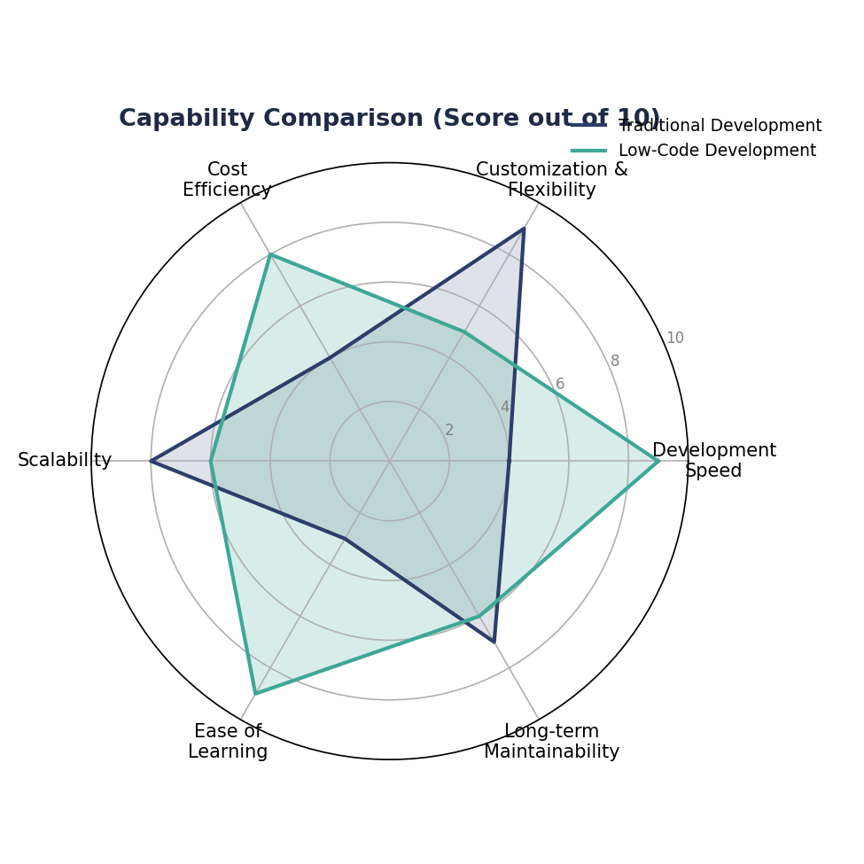
Figure 2: Relative capability scores (out of 10) across key dimensions

4. Advantages & Limitations
4.1 Traditional Development
Advantages | Limitations
Unlimited customization and control | Slower time to market
No vendor lock-in — full code ownership | Requires skilled developers
Best performance for complex systems | Higher initial cost
Scales to any level of complexity | Harder to iterate quickly

4.2 Low-Code Development
Advantages | Limitations
Rapid development and deployment | Limited deep customization
Lower barrier to entry for non-coders | Potential vendor lock-in
Faster iteration and prototyping | May struggle with high complexity
Reduced initial development cost | Ongoing platform licensing fees

5. When to Use Which Approach
Scenario | Recommended Approach | Why
Banking core transaction system | Traditional | Requires deep security, custom logic & full control
Internal HR leave-approval app | Low-Code | Simple workflow, fast turnaround, few users
High-traffic e-commerce platform | Traditional | Needs custom performance tuning & scalability
Hackathon MVP / prototype | Low-Code | Speed matters more than deep customization
Government citizen portal | Traditional | Complex compliance & integration requirements
Event registration micro-app | Low-Code | Short-lived, low-complexity, quick to launch

6. Conclusion
Neither approach is universally "better" — the right choice depends on project complexity, timeline, budget, and available skills. Low-code development is the clear winner for speed, simplicity, and accessibility, making it ideal for MVPs, internal tools, and rapid prototypes such as hackathon projects. Traditional development remains essential for large-scale, highly customized, or mission-critical systems that demand full control and long-term scalability.
Key Takeaways
- Choose low-code for speed, simplicity, and quick validation of ideas.
- Choose traditional development for deep customization and complex, large-scale systems.
- Many organizations now use a hybrid strategy — low-code for internal tools, traditional coding for core products.

